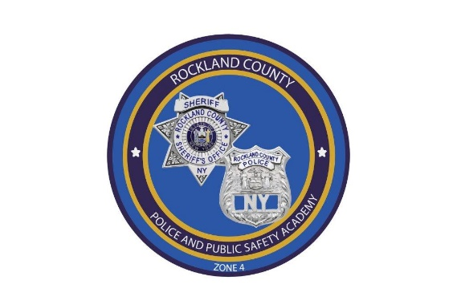
Rockland County Police & Public Safety Academy
50 Sanitorium Road, Building G
Pomona, New York 10970
845-364-8700

REGISTRATION FOR
02-2026 IS CLOSED.

01-2027 REGISTRATION DOCUMENTS WILL BE READY LATER THIS FALL.

